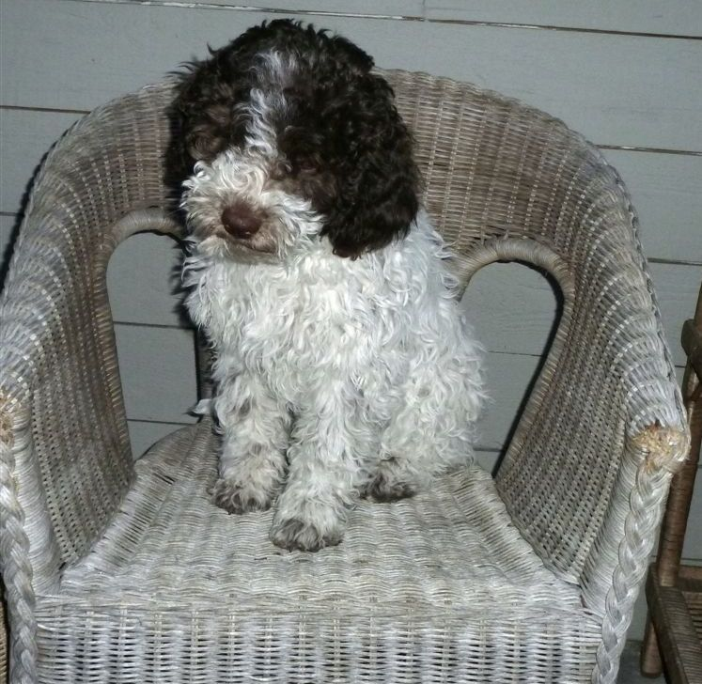

LAGOTTINO KENNEL
Lagotto Romagnolo Puppy Application Form

This form is designed to ask questions in order to help you and Lagottino Kennel decide if a Lagotto Romagnolo is the right breed for you. We will gladly help you select the right puppy.

Upon receiving this application we will be in touch with you through email or phone within 7 days. Please feel free to add anything to this application that will help us determine what personality will be the perfect fit for your family. Please do not hesitate to call us anytime if you have questions.

Today’s Date: _____________________________________
Name: ___________________________________________
Address: _________________________________________
City: ____________________________________________
Province or State: _________________________________
Area Code or Zip: _________________________________
Country: _________________________________________
Home Phone: _____________________________________
Fax: _____________________________________________
Cell Phone: _______________________________________
Email: ___________________________________________

Please check or circle your answer on the appropriate lines and answer all questions with as much information as possible.

1a. Why are you interested in the breed Lagotto Romagnolo and what research have you conducted about the breed?

1b. What date do you want to have a puppy in your home?

_______________
2a. I would like a:
􀀀 Male 􀀀 Female 􀀀 either

2b. I would like a specific color (note: colors can change as the dog matures):
􀀀 Yes 􀀀 No
Colour preferred: ____________________________

3. I would like a PET ONLY puppy and plan to spay/neuter:
􀀀 Yes 􀀀 No

4. I would like a BREEDING QUALITY puppy and am willing to have at least one litter from a female and/or to keep a male intact for breeding purposes. Breeding occurs with Lagottino’s permission.
For discussion: 􀀀 Yes 􀀀 No

5. I understand and agree that if BREEDING, I may be required to give Lagottino Kennel a puppy back of show/breed quality from the first litter:
􀀀 Yes 􀀀 No

6. I am interested in SHOW QUALITY and will not be breeding.
􀀀 Yes 􀀀 No

7. I am interested in training my dog in: (please check all that apply)
􀀀 Obedience 􀀀 Agility 􀀀 Search & Rescue 􀀀 Truffle hunting 􀀀Showing 􀀀 Breeding 􀀀 Hunting 􀀀 Other ______________

8. In what type of housing do you reside?
􀀀 Apt/Condo 􀀀 Town-house 􀀀 Single Family 􀀀 other

9. Do you live?
􀀀 In a town 􀀀 In the country 􀀀 On a farm
How many acres? _________

10. Do you:
􀀀 Own 􀀀 Rent

11. Do you have a fenced yard suitable for dogs?
􀀀 Yes 􀀀 No

12. My household consists of:
􀀀 Adults 􀀀 Children 􀀀 Dogs 􀀀Cats 􀀀Birds Other _____________
My children’s ages are: ____________
Adult ages: __________

13. I have owned dogs in the past.
Yes No

14. Please list the breed(s) you have owned:
___________________________________________________________

15a. Does anyone in the household smoke?
􀀀 Yes  No

15b. Does anyone in the household have allergies?
􀀀 Yes  No
If yes, what type? ____________________

(Note: although many with allergies do well with the Lagotto, there are no guarantees that allergy sufferers will not be affected. Potential owners should meet a Lagotto before making a final decision).

16. The temperament I expect from my dog is:
___________________________________________________________

17. Who in the household will have the major responsibility for the dog?
__________________________________________________________

18. How many hours a day would the dog normally be left alone?
__________________________________________________________

19. Do you agree to return your Lagotto Romagnolo to us for rehoming purposes if you are unable to keep it?
􀀀 Yes  No

20. Are you willing to keep the dog up to date on all its vaccinations and necessary tests as indicated by your Veterinarian?
Yes  No

21. Are you willing to have your dog seen by a vet at least once a year?
Yes  No

22. Are you willing to have the dog’s hips x-rayed (Penn-Hip or OFA) at the appropriate age and provide us with the report?
Yes  No

23a. Who is your veterinarian? __________________________________
Phone #: _____________________________________________
How frequently do you visit your vet: ________________________

23b. Do you have a regular groomer? If so who?
____________________________________________________
Phone #: _____________________________________________
How frequently do you visit your groomer?
____________________________________________________
Do you plan to maintain a short coat or a long coat on your Lagotto Romagnolo? __________________________________________

24a. Are you willing to license the dog and keep it properly identified?
􀀀Yes 􀀀No

24b. We request that you enroll in a puppy class and two levels of obedience training. Are you willing to do this?
􀀀Yes 􀀀No

24c. Have you had a puppy before?
􀀀Yes 􀀀No

24d. How do you plan to potty train your new puppy? (ie. crate, paper, etc)

25. Are you willing to provide us with follow up reports as needed?
􀀀Yes  No

26. If necessary, are you willing to pay the shipping charges for this dog?
Yes  No

27a. Please list two personal references and please include complete name and phone number.

1.

2.

27b. Please list current employer and hours out of the home for work:

27c. Are you in a financial position to pay for vet bills (both expected and unexpected)?
􀀀 Yes  No

28. Although we prefer you to come and pick up your puppy, we realize that may not be possible. If requiring shipping for your pup, which airports are closest to you?

29. List any other specifics with regards to what you are looking for in a Lagotto puppy:

(Optional) 30. What is important to you in a breeder? We strive to do our best to ensure healthy and happy dogs.

By signing this application, I (we) authorize the Veterinarian listed on this application to release information to Lagottino Kennel.

Applicant’s signature: ______________________________

Date: ______________________

